**Names: Mariam Wahdan Group: SE2**

**Malak Sadek**

**Nermeen Radwan**

**Mariam Ramadan**

**1. Project Title**

Movie Ticket Booking System

**2. Problem Statement**

Traditional movie ticket booking methods are often inefficient, requiring users to visit theaters physically or use outdated systems with limited features. Users face difficulties in checking real-time seat availability, getting notifications about upcoming movies, and accessing personalized experiences such as VIP seating or special offers. The lack of a centralized platform for multiple theaters further complicates the process.

**3. Objectives**

- Develop a web-based system that allows users to book movie tickets conveniently.

- Enable real-time seat availability tracking.

- Provide multiple theater support and categorized movie listings.

- Implement user authentication for secure bookings.

- Offer automated notifications for booking confirmations and reminders.

- Incorporate additional ticket features using a flexible system architecture.

**4. Target Users**

- Moviegoers: looking for a seamless booking experience.

- Theater Managers: manage schedules and bookings.

- Administrators :handling movie listings and user management.

**5. Technologies and Frameworks**

- Frontend: React.js

- Backend: Express.js (Node.js)

- Database: MongoSQL

- Authentication: JWT-based authentication

- Styling:Tailwind CSS / Bootstrap

**6. Expected Design Patterns**

- Abstract Factory Pattern: To create different types of movie categories dynamically.

- Observer Pattern: To notify users about booking confirmations and reminders.

- Decorator Pattern: To add special features to tickets (e.g., VIP seating, 3D glasses, free snacks).

**7. Initial High-Level System Overview**

- User Module: Authentication, profile management, booking history.

- Movie Module: Movie listings, categories, schedules.

- Theater Module: Multiple theaters with unique seat layouts.

- Booking Module: Real-time seat availability, secure payments.

- Notification System: Email/SMS reminders and booking confirmations.

- Admin Dashboard: Manage users, theaters, and schedules.

---

**Week 2: Software Requirements Specification (SRS)**

**1. Functional Requirements**

Use Cases

1. User Registration & Login

2. Browsing Movies by Category & Theater

3. Viewing Movie Schedules

4. Selecting Seats & Booking Tickets

5. Receiving Notifications for Bookings

6. Canceling or Rescheduling a Booking

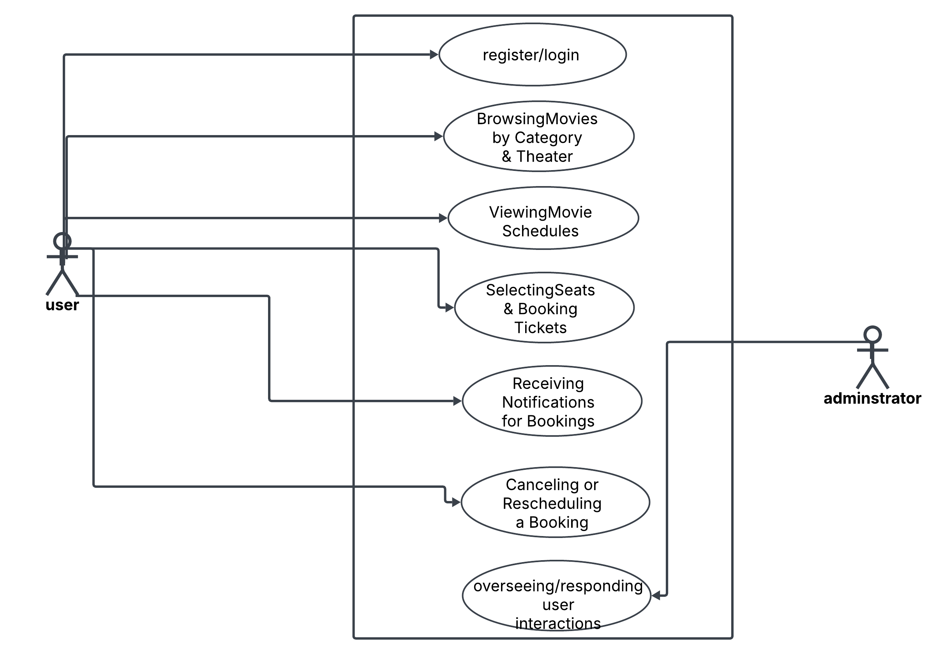

User Stories

- As a user, I want to browse movies based on categories so that I can quickly find what I like.

- As a user, I want to receive booking confirmation notifications so that I know my ticket details.

- As an admin, I want to manage movie schedules so that I can update show times easily.

**2. Non-Functional Requirements**

- Security: JWT authentication, encrypted user data.

- Scalability: Ability to handle thousands of concurrent users.

- Performance: Booking transactions should be completed within 2 seconds.

- Usability: Responsive design, intuitive UI/UX.

- Availability: 99.9% uptime guarantee.

**3. System Constraints**

- The system must support multiple theaters with unique seating layouts.

- Payments must be processed through Stripe/PayPal.

- The system should support both web and mobile browsers.

**4. Assumptions and Dependencies**

- Users have access to an internet connection.

- Theaters provide accurate movie schedules.

- Third-party services (e.g., email/SMS notifications, payment gateways) function properly.